 | European Commission  DIRECTORATE GENERAL  INFORMATICS | 

e-TrustEx - Use Case Realization
Dispatch Message

European Commission, B-1049 Brussels – Belgium, Telephone: (32-2) 299 11 11
Original Template Author: DIGIT.01.MIA – Version 2012-01
Document Control Information
Settings | Value
Directorate: | INFORMATICS
Project Name: | e-TrustEx
Document Author: | Anamaria BATRINU
System Owner: | Tanya Chetcutti
Project Manager: | Tanya Chetcutti
Revision Status: | Draft
Sensitivity: | Limited DG
Issue Date: | <Issue Date>
*Please use only the here above button to update Document Properties. Updating in the table directly will break the mechanism. If the settings in this table are not working anymore, then you can copy and paste the full table from the original template.

Document Approver(s):
(All Approvers are required. Records of each approver must be maintained.)
Approver Name | Role
[Name] | [Role]

Document Reviewers: (Records of each required reviewer must be maintained.)
Reviewer Name | Role
[Name] | [Role]

NOTE: All Reviewers in the list are considered required unless explicitly listed as Optional.

Summary of Changes:
The Document Author is authorized to make the following types of changes to the document without requiring that the document be re-approved:
- Editorial, formatting, and spelling
- Clarification

To request a change to this document, contact the Document Author or Owner.
Changes to this document are summarized in the following table in reverse chronological order (latest version first).

Revision | Date | Created by | Short Description of Changes
[1] | [09/10/2014] | [Anamaria BATRINU] | [Initial Version of approved document]
[2] | [23/10/2014] | [Anamaria BATRINU] | [Introducing an association table between message and endpoint for improving the management of routing transactions and adapting the implementation flow to take it into account.]
[3] | [02/04/2015] | [Anamaria BATRINU] | [Updated diagrams, replaced references to old asynch UC by references to the new asynch UC]
[4] | [20/09/2016] | [Anamaria BATRINU] | JIRA ETRUSTEX-1628
[5] | [17/10/2016] | [Anamaria BATRINU] | JIRA ETRUSTEX-1715

Configuration Management: Document Location
The latest version of this controlled document is stored in [this location].

- TABLE OF CONTENTS
Introduction 4
1.1 Description 4
1.2 Definitions, Acronyms, and Abbreviations 4
1.3 References 4
1.4 Overview 4
2. Design 4
2.1 Class and Data Model 4
2.1.1 Class Diagram 4
2.1.2 Class Definition and Data Model Representation 7
2.1.2.1 Endpoint 7
2.1.2.2 JMSEndpoint 7
2.1.2.3 WSEndpoint 8
2.1.2.4 AMQPEndpoint 8
2.1.2.5 MessageRouting 8
2.2 Endpoint Configuration 9
2.3 Flow Description 9
2.3.1 Create and make available the message routing configuration 10
2.3.2 Get message routing configuration and dispatch message 10
2.4 Sequence Diagram 12
2.4.1 Flow 1 - Create and make available the message routing configuration 12
2.4.2 Flow 2 - Get message routing configuration and dispatch message 13
2.5 Exceptions 13
2.5.1 For the web service endpoint dispatching 13
2.5.2 For the JMS endpoint dispatching 14
2.5.3 For the AMQP endpoint dispatching 14
2.6 Logging Information 14
2.7 Retry Policy 14

Introduction

Description

This Use Case Realization represents the implementation of section 3.1.3.6 System dispatches the message from the Process Asynchronous Message Use Case. It describes the Routing Feature of e-TrustEx, whose core functionality is the ability to route messages based on message type, which allows a message to be forwarded to a client endpoint.

Definitions, Acronyms, and Abbreviations
Acronym, Abbreviation or Definition | Explanation
UC | Use Case
UCR | Use Case Realization
JMS | Java Message Service
WS | Web Services
AMQP | Advanced Message Queuing Protocol

References
Reference Name | Owner/Author | Where Stored
e-TrustEx Software Architecture Document | Sandro D'Orazio | https://webgate.ec.europa.eu/CITnet/svn/ETRUSTEX/trunk/001%20e-TrustEx/003%20Architecture/e-TrustEx_Software_Architecture_Document.doc

Overview
This document presents the Use Case Realization as a series of views: Class Diagram view, and Sequence Diagram view, using the Unified Modelling Language (UML).

Design

Class and Data Model

Class Diagram

The main data model classes involved in the routing feature are represented by the four endpoint classes: Endpoint, JMSEndpoint, WSEndpoint and AMQPEndpoint. An association between message and the destination endpoint is kept by the class MessageRouting.

Concerning the service classes, we have the MessageDispatcherServiceActivator which is the Message Routing feature starting point, and uses other services like InterchangeAgreementService or EndpointService to retrieve relevant data, then calls the corresponding MessageDispatcher, which is in charge of converting (if necessary) and sending the message to the corresponding Endpoint.

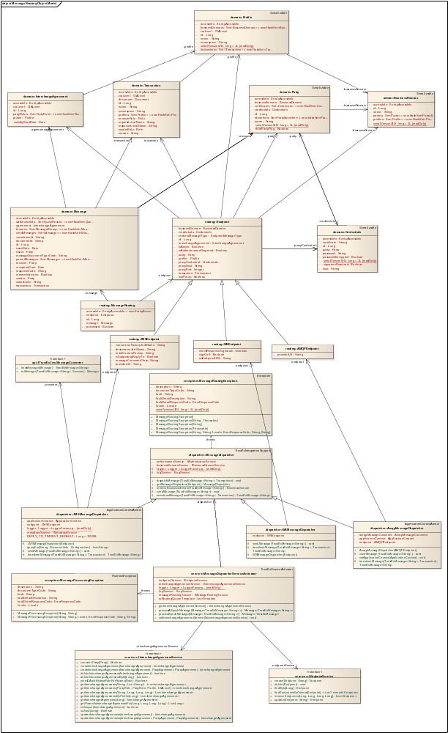

Class Definition and Data Model Representation

Endpoint
The Endpoint class is an abstraction for any type of endpoint (JMS Endpoint, WS Endpoint, AMQP Endpoint). The corresponding database table is ETR_TB_ENDPOINT. Note that when configuring an endpoint, the interchange agreement, transaction and profile fields are mutually excluded.

Property | Table column | Description
id | EDP_ID | The database id of the endpoint
credentials | EDP_CRED_ID | The credentials to be used if authentication is required in order to connect to the endpoint
transaction | EDP_TRA_ID | The transaction for which the endpoint shall be used
businessDomain | EDP_BD_ID | The business domain for which the endpoint shall be used
party | EDP_PTY_ID | The party for which the endpoint shall be used. This can also be a third party, for which a party agreement exists with the party receiver specified in the message header.
interchangeAgreement | EDP_ICA_ID | The interchange agreement for which the endpoint shall be used
profile | EDP_PRO_ID | The profile for which the endpoint shall be used
endointMessageType | EDP_MSG_TYPE | Indicates the message type the endpoint should expect
isActive | EDP_ACTIVE_FLAG | Indicates if the endpoint is active or not
isAuthenticationRequired | EDP_AUTH_FLAG | Indicates if endpoint authentication is required
useProxy | EDP_USE_PROXY | Indicates if a proxy shall be used or not
proxyHost | EDP_PROXY_HOST | The proxy host, if a proxy is used
proxyPort | EDP_PROXY_PORT | The proxy port, if a proxy is used
proxyCredential | EDP_PROXY_CRED_ID | The credentials to use for proxy authorization, if proxy is used and such credentials are required

JMSEndpoint
JMSEndpoint class will be used when dispatching messages to a JMS queue. The corresponding database table is ETR_TB_ ENDPOINT_JMS.

Property | Table column | Description
All properties of Endpoint | -
providerUrl | EDP_JMS_PROV_URL | The URL of the JMS provider
initalContextFactory | EDP_JMS_INIT_CONT_FACT | The initial JNDI context factory to be used
destinationJndiName | EDP_JMS_DEST_JNDI_NM | The destination queue where the message will be sent
connectionFactoryJndiName | EDP_JMS_CFACT_NM | The JMS connection factory to be used
messageConverterClass | EDP_JMS_MESS_CON_CLASS | The java class use for converting the message to send in a specific format, if such format is needed in the receiver system.
isSupportingReplyTo | EDP_REPLY_TO_FLAG | Flag indicating if a temporary reply queue is used

WSEndpoint
WSEndpoint class will be used when dispatching messages to a web services endpoint. The corresponding database table is ETR_TB_ ENDPOINT_WS.

Property | Table column | Description
All properties of Endpoint | -
wsEndpointURL | EDP_WS_URL | The URL of the web services endpoint
signCall | EDP_WS_SING_FL | Indicates if the message should be signed
checkResponseSignature | EDP_WS_REQUIRE_SIGNED_RESP_FL | Indicates if the response should be signed

AMQPEndpoint
AMQPEndpoint class will be used when dispatching messages to an AMQP endpoint. The corresponding database table is ETR_TB_ ENDPOINT_AMQP.

Property | Table column | Description
All properties of Endpoint | -
providerURL | EDP_AMQP_PROV_URL | The URL of the AMQP provider

MessageRouting
MessageRouting class is used to keep track of the messages that have been successfully processed and dispatched to the corresponding endpoint, or, on the contrary, those that could not be successfully dispatched. Its corresponding database table is ETR_TB_MESSAGE_ROUTING.

Property | Table column | Description
id | MR_ID | The database id
message | MR_MESSAGE_ID | The message that is being or has sent for dispatching
endpoint | MGR_ENDPOINT_ID | The message destination endpoint
processed | MGR_PROCESSED_FLAG | Indicates if the dispatching of the message to the endpoint has been successful or not
creationDate | CRE_DT | Creation date
creationId | CRE_ID | Creation username
modificationDate | MOD_DT | Modification date
modificationId | MOD_ID | Modification username

Endpoint Configuration
The Message Dispatching feature is configurable in the system's database, at endpoint level, by specifying
- the business domain
- the receiver party (mandatory in all cases) and
- either
  - the interchange agreement (for a specified message type and a sender party),
  - the transaction type (for a specified message type) or

  - the profile (for a group of specified message types)
It is possible to configure a message with zero or more endpoints.
The receiver party might be replaced by one of its delegated third parties when configuring routing per transaction or profile.
Endpoints for routing all message types corresponding to the profile

Endpoints for routing a specific type of message
Endpoints for routing all message types in the business domain

Profile

Interchange Agreement
Transaction

Endpoints for routing a specific type of message for a sender party

Flow Description

This use case realization starts after the message is processed by the business service, and describes how the result (a message of type TrustExMessage) is dispatched to the receiver party messaging endpoint, which can be a JMS queue or a web services endpoint. In the case of a web services endpoint, the receiver party system shall implement the exact same interface as e-TrustEx (submit bundle for example).

After the business services process the message, the Message Dispatching feature is activated and the dispatching of the message is done in two flows that complement each other.

The first flow is dealing with getting all endpoints corresponding to the message and creating the corresponding message routing configurations that will be sent on a JMS routing queue, from where the second flow will enter into action by reading each configuration from the JMS routing queue, dispatching the message appropriately and updating the message routing configuration with status dispatched in case of success.

Create and make available the message routing configuration

The first flow configures the message routing and contains the following operations are executed:

F1 - Step 1. System receives as input a message of type TrustExMessage.

F1 - Step 2. System retrieves the interchange agreement, the profile and the transaction corresponding to the current message transmission, as well as the receiver party. See mapping bellow:

Information | Mapping
Interchange agreement | Message header – interchange agreement id
Profile | The profile of the interchange agreement previously mapped
Transaction | MessageError: Reference source not found header – the transaction type id
Receiver party | MessageError: Reference source not found header – the receiver party id

F1 - Step 3. System retrieves all the endpoints corresponding to:
- the current interchange agreement and the receiver party
- the interchange agreement profile and the receiver party
- the current transaction and the receiver party
- the current transaction and the delegated parties of the receiver party (these delegated parties need be authorized on the current transaction)
- The current profile and the third parties having an agreement with the receiver party. If no transactions are specified at the level of the party agreement, the third party sees all messages; otherwise the third party sees only the messages corresponding to the specified transactions. This allows the routing to supplier portal or other portals for instance.

F1 - Step 4. For each active endpoint
- the system creates a MessageRouting record, by specifying the message id, the endpoint id and isDispached filled with false
- the system builds a JMS message containing
  - the log correlation id
  - the message correlation id (used for JUSTICE messages)
  - the transaction id (that will be used for building the SOAP message when dispatching via webservice endpoints)
  - the id of the MessageRouting record just created
and sends it to jms/routingQueue, from where it will be taken and processed in a different flow (see 2.3.2 Get message routing configuration and dispatch message)

The system logs
- the creation of each association between the message and endpoint configurations (providing a meaningful description and the id of the created record)
- the fact that message is waiting for dispatching by providing a meaningful description containing the message id, and the message routing configuration ids (double logging: console and database)

Get message routing configuration and dispatch message

The second flow is implemented by RoutingQueueMessageListener which listen for new messages on the jms/routingQueue, and for each message retrieved from the queue performs the following operations:

F2 - Step 1. The system retrieves the log correlation id that will be used for any logging done during this flow, and the id of the MessageRouting configuration to use.
F2 - Step 2. The system retrieves the MessageRouting configuration corresponding to the previously retrieved id. If the message has already been dispatched, the system creates a log record providing a description containing the message id and the message routing configuration id, and proceeds to the next message in the queue.
F2 - Step 3. The system checks that the endpoint corresponding to this configuration is active. This double check is done with the purpose to avoid dispatching messages to an endpoint that has been deactivated in the meanwhile (for example, because it does not exist anymore). If the endpoint is inactive, the system creates a log record with a description specifying that the message could not be dispatched to the endpoint because the endpoint status is inactive (message and endpoint ids shall be included in the log record). The processing of the JMS message stops and System proceeds to next message in the queue.
F2 - Step 4. The endpoint is active. The system dispatches the message:
- For the JMS endpoint:
  - System logs the start of dispatching process by providing the message id, the provider's URL and the JMS queue name
  - System sets up a JMS connection by providing the credentials in case the authentication is required
  - Systems converts the message using the message converter class if such class is configured, or uses the eTrustEx converter if not
  - System sends the message into the specified queue
  - System logs the successful dispatching by providing the message id, the provider's URL and the JMS queue name
- For the web services endpoint:
  - System logs the start of dispatching process by providing the message id and the endpoint URL
  - System sets the web service URL
  - System sets the credentials if authentication is required
  - If a proxy is used, System sets the proxy host and port; proxy credentials are also set if configured
  - System calls the web service
  - System logs the successful dispatching by providing the endpoint URL
- For the AMQP endpoint
  - System logs the start of dispatching process by providing the message id and the AMQP provider URL
  - System converts the message using a SOAP JMS template
  - System sets the provider URL
  - System sets the credentials if authentication is required
  - System sends the message
  - System logs the successful dispatching by specifying the AMQP provider URL
F2 - Step 5. If the message is successfully dispatched, the system updates the message routing configuration, by changing isDispatched flag to true. In case there was an error, isDispatched flag is not changed; the System records the error and applies the retry policy described in section 2.7 Retry PolicyRetry Policy.

Sequence Diagram

Flow 1 - Create and make available the message routing configuration
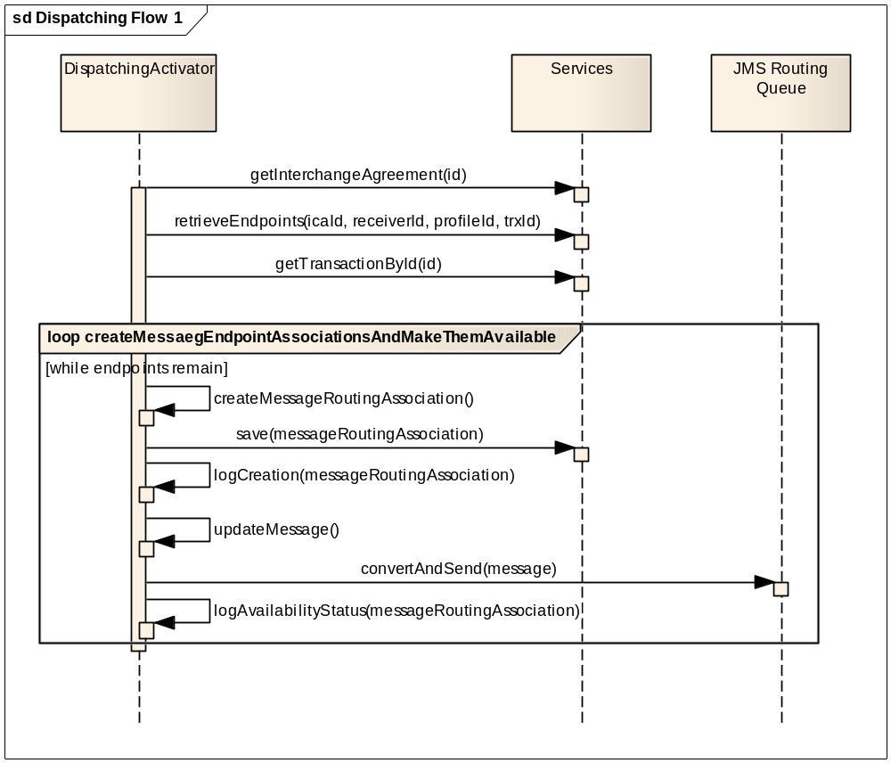

Flow 2 - Get message routing configuration and dispatch message
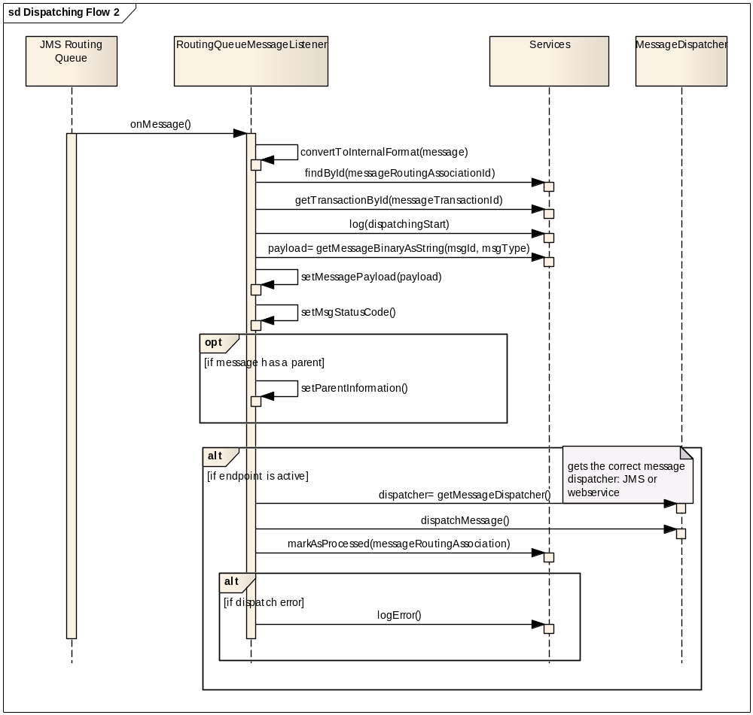

Exceptions

All exceptions and errors that may happen during the first flow generate a double log: a console log (in case database is down) and a database log record with message routing configuration error, and will end the dispatching flow.

All exceptions and errors that may happen in the second flow generate a double log: a console log (in case database is down) and a database log record with dispatching error. The concerned message will be dealt with as specified in section 2.7 Retry Policy.

The mapping of the information in the log record is done as described in section 2.6 Logging Information.

The subsections below present a more detailed view on the exceptions generated during dispatching.

For the web service endpoint dispatching

- A message transformation error will result in a MessageRoutingException with an error response code of TECHNICAL_ERROR and a message "Error when transforming the message before dispatching".
- A message sending error will result in a MessageRoutingException with an error response code of TECHNICAL_ERROR/CONFIGURATION_ERROR and a message "Error when calling the web service endpoint".

For the JMS endpoint dispatching

- A wrong configuration of the message conversion class will result in a MessageRoutingException with an error response code CONFIGURATION_ERROR and a message "Specified Message Converter not found".
- A message conversion error will result in a MessageProcessingException with an error response code TECHNICAL_ERROR and a message "Failed to convert message to JMS message".
- A wrong configuration of the JMS context will result in a MessageRoutingException with an error response code CONFIGURATION_ERROR and a message "Unable to initialize JNDI context".
- Not being able to connect to the destination queue will result in a MessageRoutingException with an error response code TECHNICAL_ERROR and a message "Unable to establish connection to the JMS destination".

For the AMQP endpoint dispatching

Any error happening during the AMQP dispatching will result in a MessageRoutingException.

Logging Information
Logging information is stored in ETR_TB_LOG table. Please note that each creation of a database log is preceded by the creation of a console log to cover for the case in which the database might be unavailable. The following information mapping is used (the table fields not present in the mapping are not concerned by the dispatch logging):

Table field | Information | On success | On error
LOG_ID | Log identification information – auto generated | x | x
LOG_TYPE | SUCCESS on successful operation, ERROR or EXCEPTION on business errors or exceptions | x | x
LOG_OPERATION | Message dispatch operation: MSG_DISPATCH | x | x
LOG_DESCRIPTION | A user friendly message | x | x
LOG_LARGE_VALUE | The stacktrace, where it is the case | - | x
LOG_CORRELATION_ID | The log correlation identifier | x | x
LOG_DOCUMENT_ID | The message document identifier | x | x
LOG_BUS_CORRELATION_ID | The message correlation identifier | x | x
LOG_MSG_ID | The id of the message to route | x | x
LOG_BUSINESS_DOMAIN | The business domain in which the operation takes place | x | x
CRE_DT | Creation date: the system date | x | x
MOD_DT | Modification date: the same with creation date. It never changes. | x | x
CRE_ID | Creation user, which is the system user TRUSTEX. | x | x

Retry Policy
The system will retry to dispatch the message 48 times with 30 minutes of delay between each retrial. If all retrials are unsuccessful, the System logs the information and proceeds to the abortion of dispatching. The retry policy covers 24 hours.

Message refers to a message of type TrustExMessage, obtained after the processing of the original message.

